Test Case: tc002_SPX_Dev5_Crear_Requisicion_Spot_Tipo_Cobro_Project
Step 1 - Enter username and password and click to button Enter: Credentials Entered
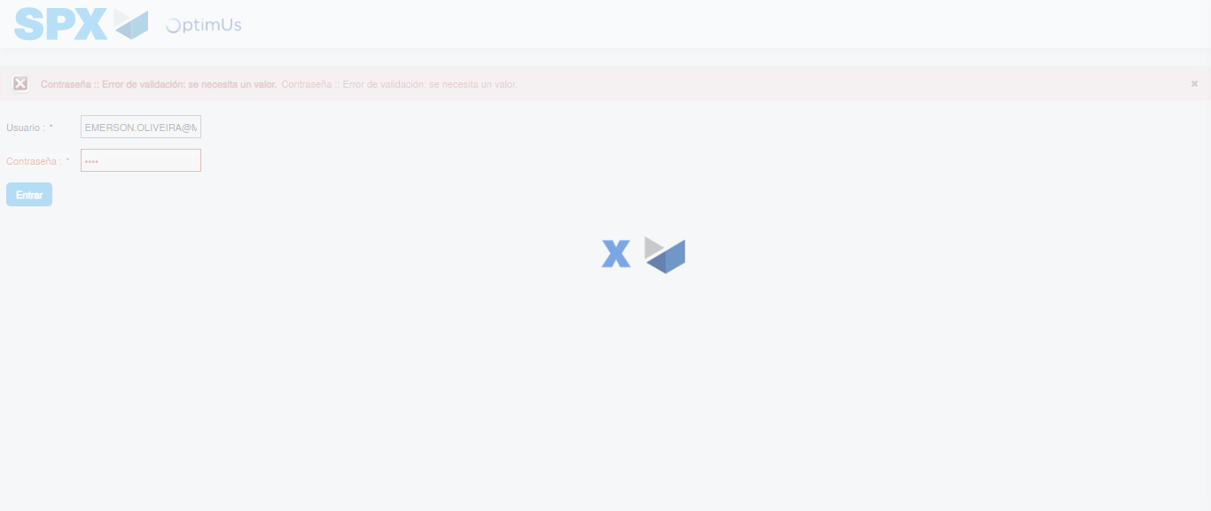Image file-name: QC_Testing-tc002_SPX_Dev5_Crear_Requisicion_Spot_Tipo_Cobro_Project-1785974808389

Step 2 - Select to UEN and Access to Spot Buy Requisitions : UEN Correctly selected and Correct access
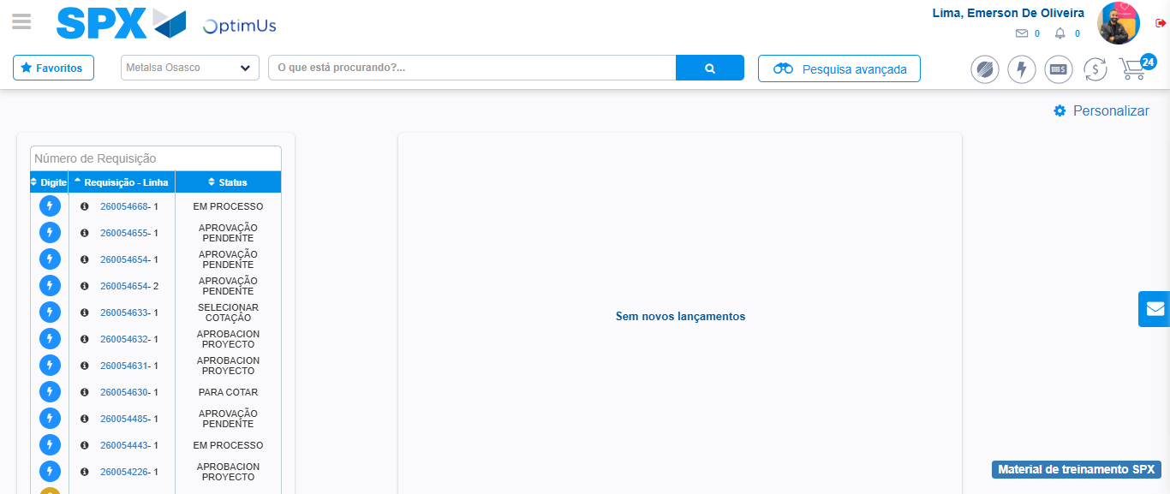Image file-name: QC_Testing-tc002_SPX_Dev5_Crear_Requisicion_Spot_Tipo_Cobro_Project-1785974844624

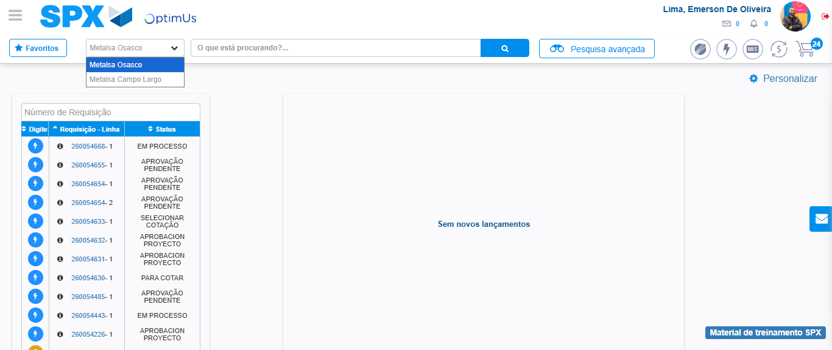Image file-name: QC_Testing-tc002_SPX_Dev5_Crear_Requisicion_Spot_Tipo_Cobro_Project-1785974847087

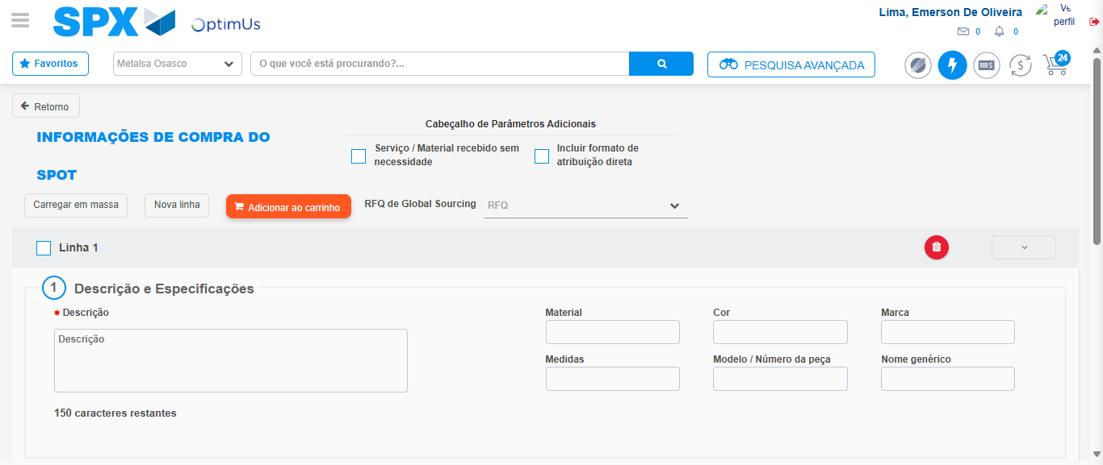Image file-name: QC_Testing-tc002_SPX_Dev5_Crear_Requisicion_Spot_Tipo_Cobro_Project-1785974856319

Step 3 - Data Capture Spot Buy Requisition: Data captured correctly
Image file-name: QC_Testing-tc002_SPX_Dev5_Crear_Requisicion_Spot_Tipo_Cobro_Project-1785974856549

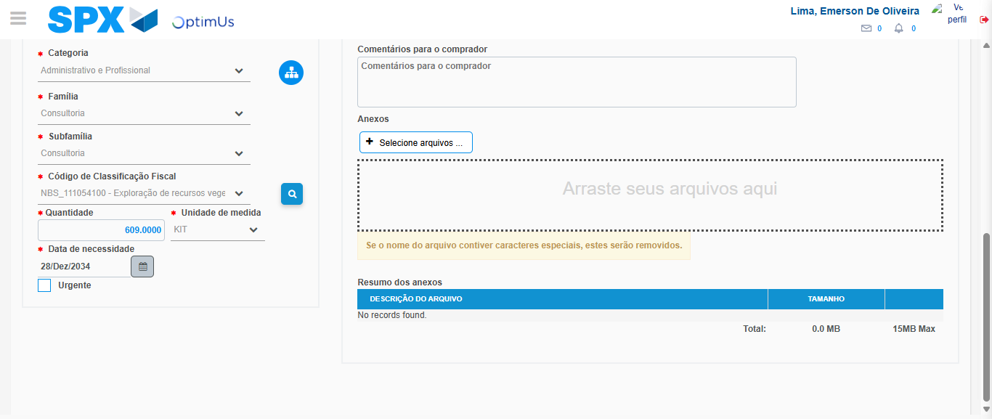Image file-name: QC_Testing-tc002_SPX_Dev5_Crear_Requisicion_Spot_Tipo_Cobro_Project-1785974874080

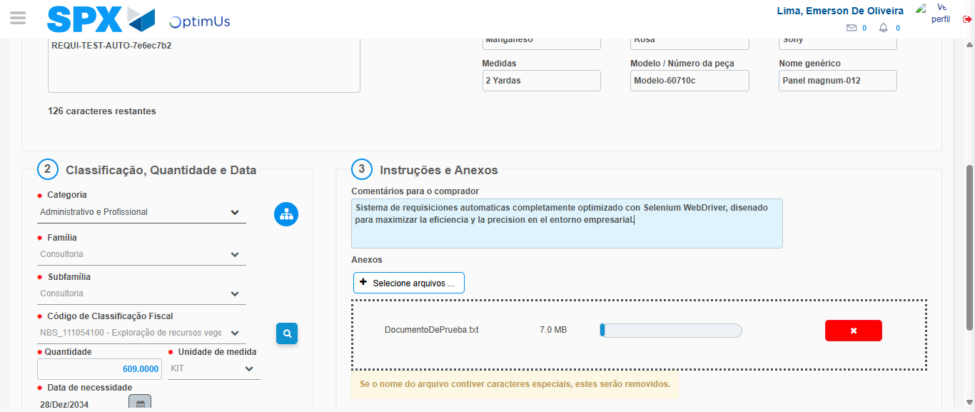Image file-name: QC_Testing-tc002_SPX_Dev5_Crear_Requisicion_Spot_Tipo_Cobro_Project-1785974874849

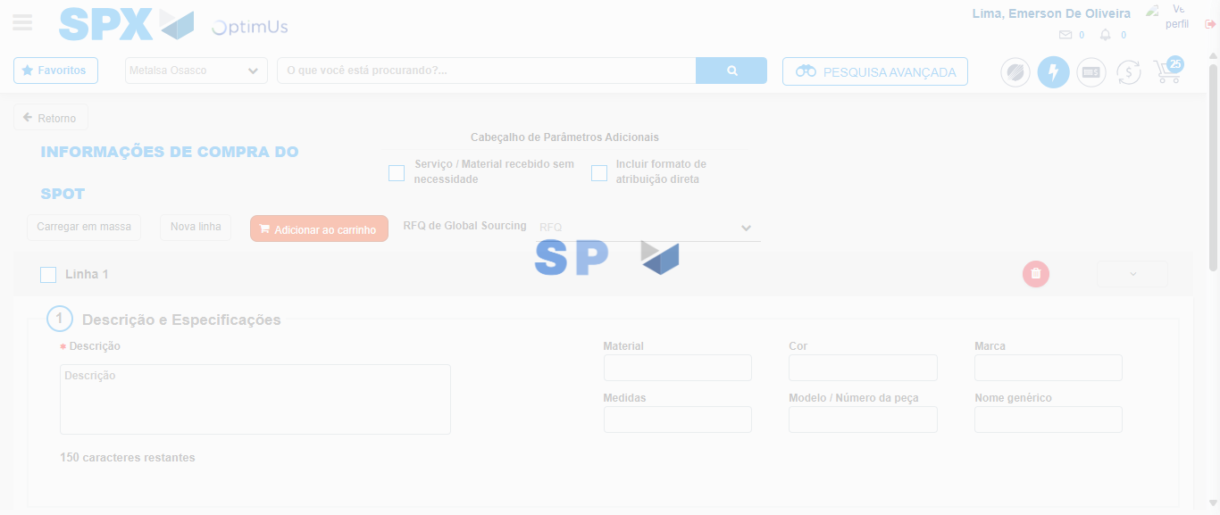Image file-name: QC_Testing-tc002_SPX_Dev5_Crear_Requisicion_Spot_Tipo_Cobro_Project-1785974877868

Step 7 - Return to Main Page SPX : Return to Main Page SPX
Image file-name: QC_Testing-tc002_SPX_Dev5_Crear_Requisicion_Spot_Tipo_Cobro_Project-1785974844624

Image file-name: QC_Testing-tc002_SPX_Dev5_Crear_Requisicion_Spot_Tipo_Cobro_Project-1785974847087

Image file-name: QC_Testing-tc002_SPX_Dev5_Crear_Requisicion_Spot_Tipo_Cobro_Project-1785974856319

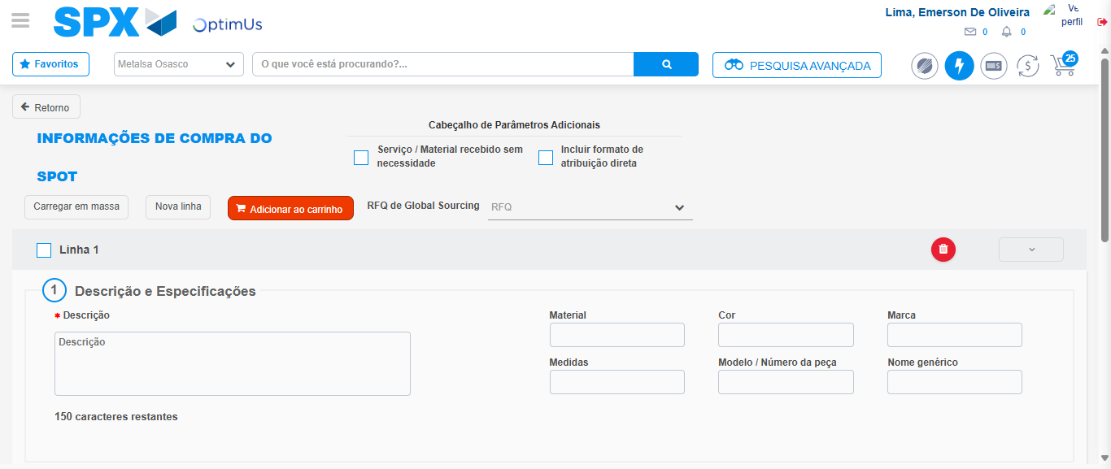Image file-name: QC_Testing-tc002_SPX_Dev5_Crear_Requisicion_Spot_Tipo_Cobro_Project-1785974880100

Image file-name: QC_Testing-tc002_SPX_Dev5_Crear_Requisicion_Spot_Tipo_Cobro_Project-1785974880286

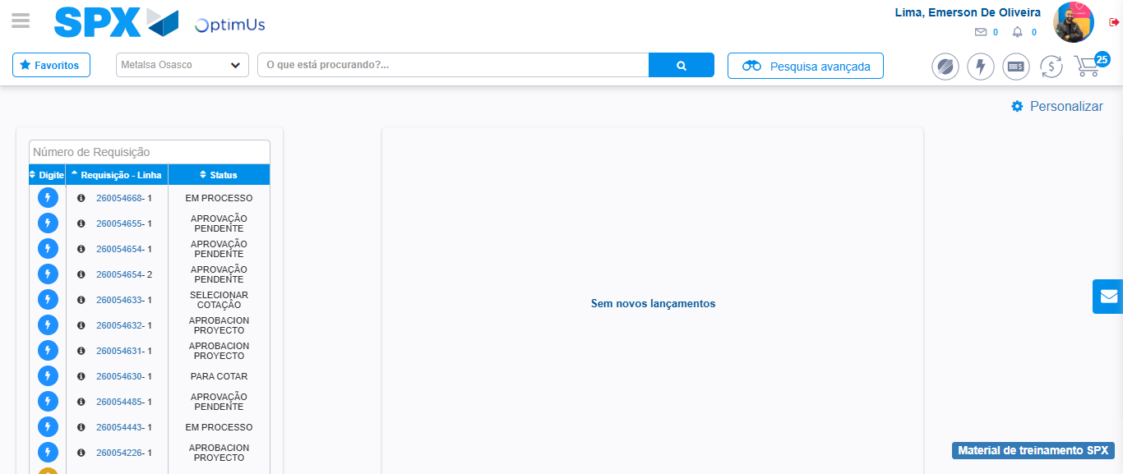Image file-name: QC_Testing-tc002_SPX_Dev5_Crear_Requisicion_Spot_Tipo_Cobro_Project-1785974901387

Step 8 - Log Out : Log Out SPX
Image file-name: QC_Testing-tc002_SPX_Dev5_Crear_Requisicion_Spot_Tipo_Cobro_Project-1785974901587

